IRRI’s Irrigated Breeding Program

Breeding Objectives

- High Yield Potential
- Short Growth Duration
- Superior Grain Quality
- Multiple Disease and Insect Resistance
- Nutritional Quality (Iron/Zinc)
Hybridization Program
Various donors are grown in Hybridization Block. These are staggered sown 3 times each season at 2-weeks interval.

F1 Nursery
Types of crosses

Single crosses
Backcrosses
Three way/Top crosses

Number of crosses – typically 200-250 per year.
Cross designation (e.g. IR80369).

Types of Crosses

Further improvement in Indica germplasm for Yield, grain quality and incorporation of resistance to diseases and insects.

Released varieties x Elite Indica Lines
Elite Indica Lines x Elite Indica Lines
Elite Indica Lines x Basmati Type Lines

Developing Basmati Type Germplasm

Basmati X Elite Indica Lines
Basmati x Basmati Type Derivatives
Basmati Type Derivatives x Basmati Type Derivatives

Improving Tropical Japonica NPTs for tropics and temperate regions (Korea)

Tropical Japonica x Tropical Japonica crosses
Tropical Japonica x Korean Varieties

Further Improvement in NPTs for Yield, grain quality and incorporation of resistance to diseases and insects.

Improved NPTs x Improved NPTs
Improved NPTs x Released Indica Varieties
Improved NPTs x Elite Indica Varieties

F2 Nursery

 | Blast Screening
Protected | + | -
Unprotected | + | -

Blast Nursery
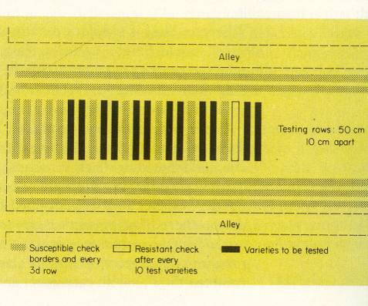

Protected
In general susceptible to diseases and insects- chemical protection given.
Screen for blast- Reject Susceptible populations.
Unprotected
Spreader rows (TN1) grown to maximize natural disease/insect pressure.
In general resistant to diseases and insects- no chemical control practiced.
Screen for blast- Reject Susceptible populations.
- Space planted 35 x 25 cm.
- Population size from 2,500- 5,000 individuals
- Inoculate with BB Race1/Race2
Rogue undesirable plants.

Harvest desirable plants (100-200 plants).

Pedigree nursery
We grow four nurseries/year.

January PN- Unprotected
May PN- Protected
July PN- Unprotected
November PN- Protected

- Space planted 30 x 20 cm
- Every 20th row is a check variety (4 Checks)
- 14,000 to 20,000 rows (4 ha).

Material is screened for
Blast
BB Race1 and 2
BPH (Biotypes 1, 2 and 3),
GLH
Grain quality
Grain length
Grain shape
Chalkiness
Amylose content
Gelatinization temperature
Aroma
Grain elongation
Days to Flower

Naming convention

Naming of pedigree at IRRI is based on the cross number and serial numbers of selected plants. IR numbers are assigned consecutively to the crosses made at IRRI just before the hybrid seeds are incubated for germination. When plant selections are made from F₂ and subsequent generations of an IR cross, numerical designations are given for each breeding line. For example, IR2061-214-3-8-2, a breeding line named IR28 in 1974, was selected from the cross IR2061. Plant selections from the F₂ of this cross (number 806) were grown in the pedigree nursery as F₃ rows, which were consecutively designated as IR2061-1, IR2061-2 and so on up to IR2061-806. From selection 214, three plants were selected, planted in the pedigree nursery as F₄ selections and designated as IR2061-214-1, IR2061-214-2 and IR2061-214-3. From selection IR2061-214-3, 10 plants were again selected and planted in pedigree nursery as F₅ rows. These selections were designated as IR2061-214-3-1 up to 2061-214-3-10. From selection IR2061-214-3-8, three plant selections were made and planted in the pedigree nursery as F₆ rows. These were designated as IR2061-214-3-8-1, IR2061-214-3-8-2 and IR2061-214-3-8-3. At maturity selection IR2061-214-3-8-2 appeared uniform and seeds of the entire row were bulk harvested and used for yield evaluation in replicated trials and other tests. This line was evaluated in the lowland rice performance trials conducted by the Rice Varietal Improvement Group of the Philippine Seed Board and on the basis of its superior performance, was released as IR28.

Selection in F3 and subsequent generations

F3 single rows
F4 onwards at least 3 rows.
Selection is practiced between rows/within rows- at least 3 plants selected.

Pedigree Nursery Field Book
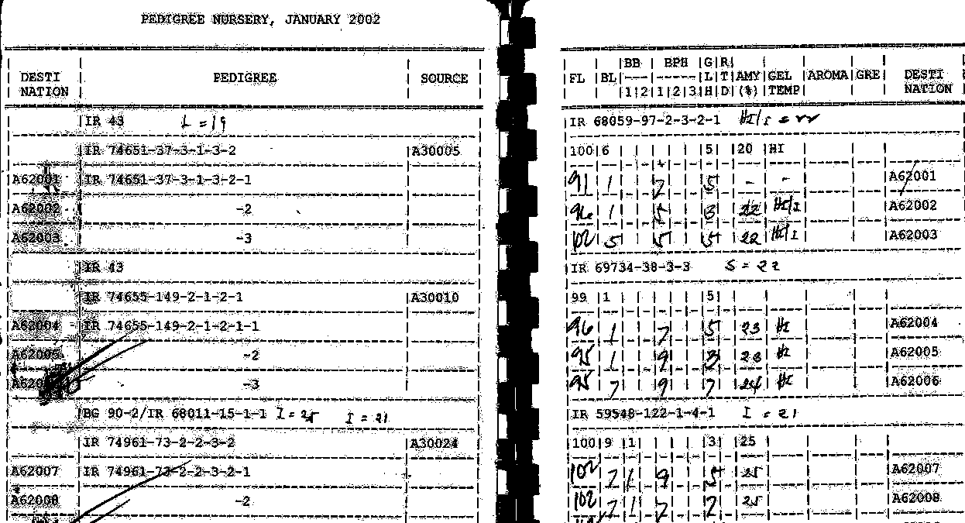

Observational Yield Trial

Promising homozygous progenies are grown replicated plots of 6 m long plots of 6 rows.

Replicated Yield Trial

Around 350 promising progenies are evaluated in randomized complete block design with 3 replications. Each plot consists of 10 rows of 5 m length. Yield is recorded at 14% moisture content from 6 m² harvested area. Data on the following traits are recorded.

Blast
BB Race1 and 2
Tungro
BPH (Biotypes 1, 2 and 3)
GLH
Grain quality
Grain length
Grain shape
Chalkiness
Amylose content
Gelatinization temperature
Gel Consistency
Aroma
Grain elongation
Milling %
Days to Flower
Days to maturity
Plant Height
Tiller Number
Grain yield

