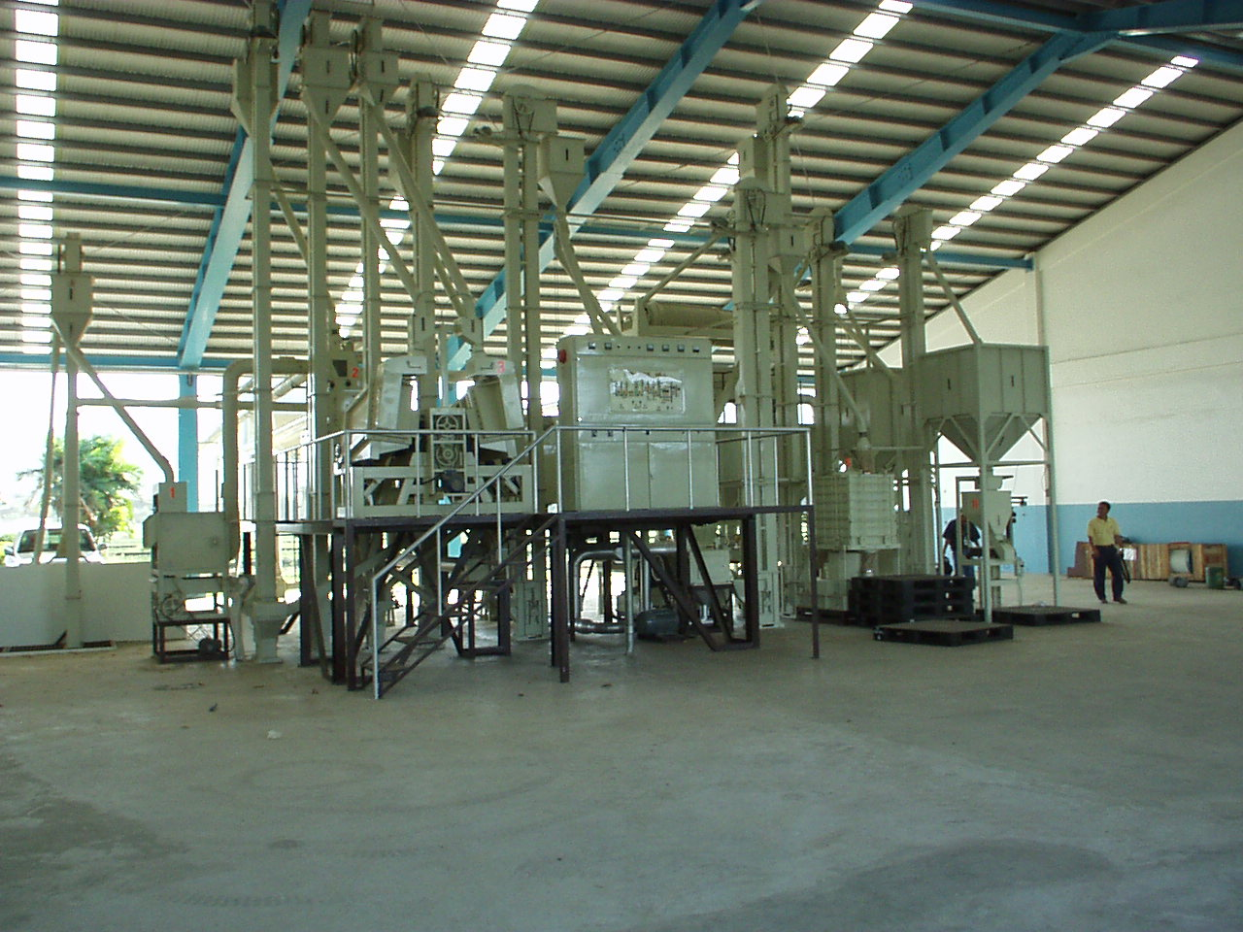
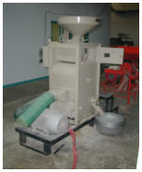
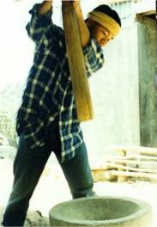
Contents
1 Introduction 3
2 The Rice Grain 3
2.1 Physical Structure 3
2.2 Chemical Composition of Milled Rice 3
3 Rice Milling 4
3.1 One pass milling 4
3.2 Two Stage Milling 4
3.3 Multiple pass rice milling 5
3.3.1 Pre-cleaning 5
3.3.2 Removing the husk 6
3.3.3 Paddy separation 8
3.3.4 Whitening or Polishing Process 9
3.3.5 Separation of white rice 10
3.3.6 Rice Mixing 10
3.3.7 Mist Polishing 11
3.3.8 Rice Weighing 11

Introduction
The objective of a rice milling system is to remove the husk and the bran layers from paddy rice to produce whole white rice kernels that are sufficiently milled, free of impurities and contain a minimum number of broken kernels. The milling yield and quality of rice is dependent on the quality of the paddy, the milling equipment used and the skill of the mill operator.

The Rice Grain
The rice grain has both physical and chemical characteristics.

Physical Structure
A rice grain is made up of an outside husk layer, a bran layer, and the endosperm, see Figure 1. The husk layer (lemma and palea) accounts for 20% of the weight of paddy and helps protect the grain kernel from insect and fungal attack. When the husk is removed, the rice is called brown rice. Brown rice contains the bran layer and the endosperm. The bran layer is made up of the pericarp and testa, the aluerone layer and the embryo. The degree to which this bran layer is removed is known as the milling degree. The desired amount of bran removed depends on the country. In Japan, the aluerone layer is often not removed however in many other countries all bran layers are removed to give very highly polished rice. The storage life of milled rice is improved when all of the bran layers are removed.
Table 1: Physical characteristics of paddy rice
Physical characteristic | Percentage
Paddy | 100
Husk | 20
Brown rice | 80
Meal  Pericarp and testa (5-6%)  Aluerone (1%)  Embryo (3%) | 8-10
White rice | 70-72

Chemical Composition of Milled Rice
Rice at 12% moisture contains approximately 80% starch and 7% protein. (Currey, 1984) Starch occurs in the endosperm as small many-sided granules while protein is present as particles that lie between the starch granules. Rice grain also contains sugars, fat, dietary fiber and minerals, see Table 2.
Table 2: Chemical composition of rice and bran
 | Brown rice | White rice | Bran
Water (%) | 13-14 | 13-14 | 13-14
Starch (%)  -amylose | 68-70 | 80 | 9
Starch (%)  -amylose | 28-30 | 33 | 6
Protein (%) | 6-8 | 6-7 | 14
Fat | 3 | 1 | 20
Fiber | 2-3 | 0.5 | 25
Crude ash | 1-1.5 | 0.5 | 9-10

Rice Milling
Rice milling is the process of removing the husk and bran layer to produce white rice. Rice milling can be undertaken as:
- A one step milling process where the husk and the bran are removed in one pass and white rice is produced directly from the paddy.
- A two-step process where the husk and the bran are removed separately, and brown rice is produced as an intermediate product.
- A multistage process where rice passes through a number of different operations and machines from paddy to white rice.

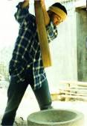
One pass milling
Pestle and mortar
Hand pounding of paddy in a mortar with a pestle is still practiced in some remote areas. Pounding the paddy induces upward and downward forces on grain against grain that removes the husk and some bran layers. The pounding also results in a high percentage of broken kernels. The final cleaning is done by winnowing and gravity separation by hand.
The steel single pass mill
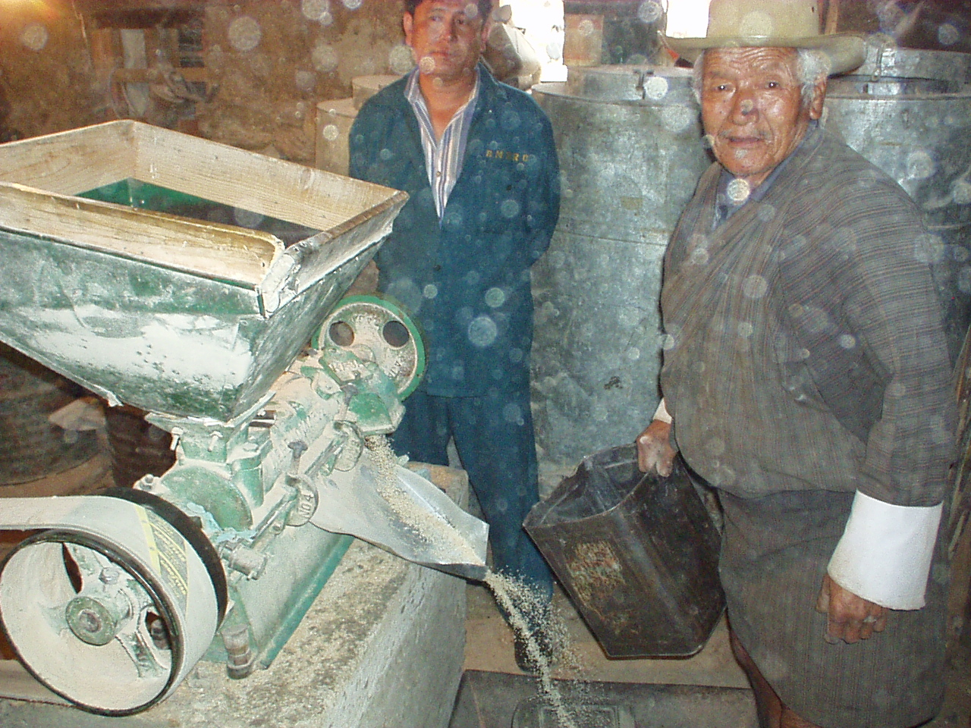
The single pass rice mill is an adaptation of the "Engleberg" coffee huller. This type of mill is still very popular in many of the poorer rice-growing countries and is widely used for custom milling of household rice. It is also still popular for milling parboiled rice in Bangladesh and many African countries. This mill is a steel friction type mill and uses very high pressure to remove the hull and polish the grain. This results in many broken kernels, a low white rice recovery of 50-55% and head rice yields of less than 30% of the total milled rice. The fine brokens are often mixed in with the bran and the ground rice hull and this is used for animal feed. The poor performance of the Engleberg mill has led some governments to discourage its use and in many Asian countries, the Engleberg mills can no longer be licensed to operate as service or commercial mills.

Two Stage Milling
Compact Mill
Two stage mills are often called compact rice mills and in many countries have superseded the Engleberg mill. The two-stage mill has separate hulling and polishing processes. Rubber rollers remove the husk and the brown rice is then polished with a steel friction whitener similar to the Engleberg. These mills have a capacity of between 0.5 to 1 ton per hour paddy input and are often used for custom milling in the rural areas. The milling performance of the compact rice mill is superior to the single pass Engleberg huller with milling recoveries normally above 60%.

Multiple pass rice milling
Commercial Mill
The milling process in larger commercial mills combines a number of operations that produces higher quality and higher yields of white rice from paddy or rough rice. The process involves:
- Pre-cleaning the paddy prior to milling
- Removing the husk or outer layer from the paddy
- Polishing or whiting the brown rice to remove the bran layer
- Separating the broken grains from the whole kernels
- Bagging the milled rice
- Managing the by-products.

Pre-cleaning
When paddy comes into the mill it contains foreign material such as straw, weed seeds, soil and other inert material. If this is not removed prior to hulling the efficiency of the huller and the milling recovery are reduced.
Most pre-cleaners separate three groups of materials:
- The first separation is done by scalping or removing the objects that are larger than the grain. Either a flat oscillating screen or a rotary drum screen that allows the grain to pass through but retains straw can do this.
- The second separation retains the grains but allows broken grains, small stones and weed seeds to pass through. An air aspirator may also be incorporated to remove the dust and the light empty grains
The capacity of the paddy pre-cleaner is usually based on the capacity of the rice mill. A pre-cleaner for a 3-ton/hr rice mill would normally have a 5 ton/hr cleaning capacity.
Types of pre cleaners
Grain pre-cleaners can be classified according to their cleaning mechanism. These are:
1. Oscillating Sieve type
Oscillating sieve pre-cleaners are simple and often made locally. The machine consists of two sieves of different sizes depending on the size and shape of the grain. The top sieve has a slotted profile larger than the bottom and both screens can be changed to suit the grain size or crop type.
2. Aspiration cum Oscillation Type
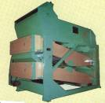
The aspirator grain cleaner removes lighter impurities such as dust, dirt, chaff and straw by blowing or sucking air through the mass of falling grain and removing these light impurities in the air stream. Impurities that are not removed by the air are then separated from the grain using oscillating sieves. The sieving action of this machine is similar to the sieve oscillation cleaner. Some cleaners are also equipped with magnets to remove ironic particles. Aspiration style cleaners can have either single or double action aspiration
3. Rotary Cleaner
This machine consists of one or two drums; each drum is fitted with mesh of different sized hexagonal or square perforation and an oscillating sieve. Foreign matter larger than the grain is removed as the paddy or rice passes through the drums. Paddy then flows onto the oscillating sieve to separate heavier impurities such as stone.
There are two types of rotary cleaner:
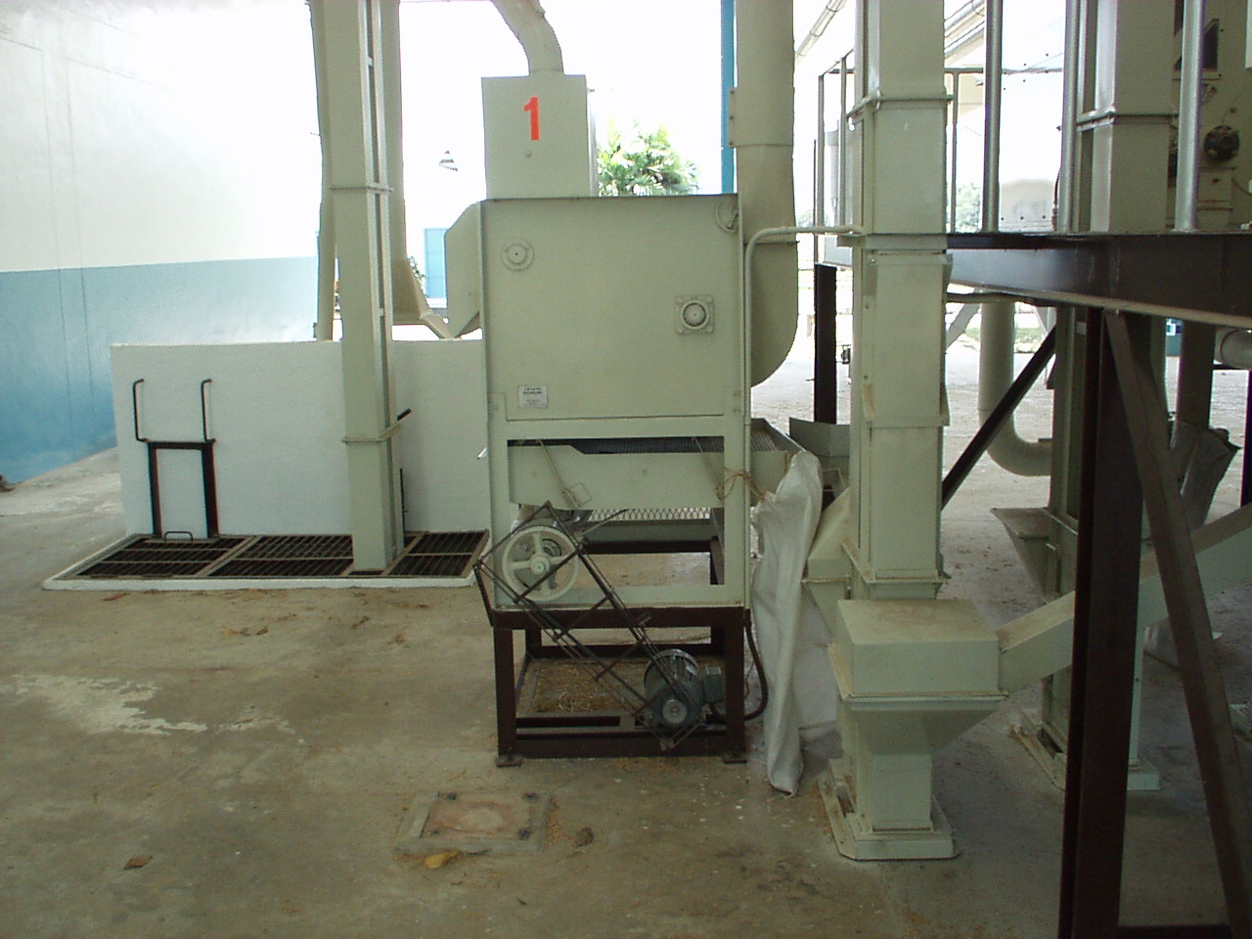
Single drum with aspirator and oscillation sieve. The single drum aspirator utilizes a single drum to separate large, light and heavy impurities. Lighter impurities are separated by suction aspiration and the oscillation sieves separate heavier impurities such as sand.
Double drums with aspirator. This machine has two rotation drums with each drum having a different size hole on the wire mesh. It utilizes an aspirator to separate light impurities. This machine is typically used for cleaning freshly harvest paddy.

4. De- stoner with aspiration
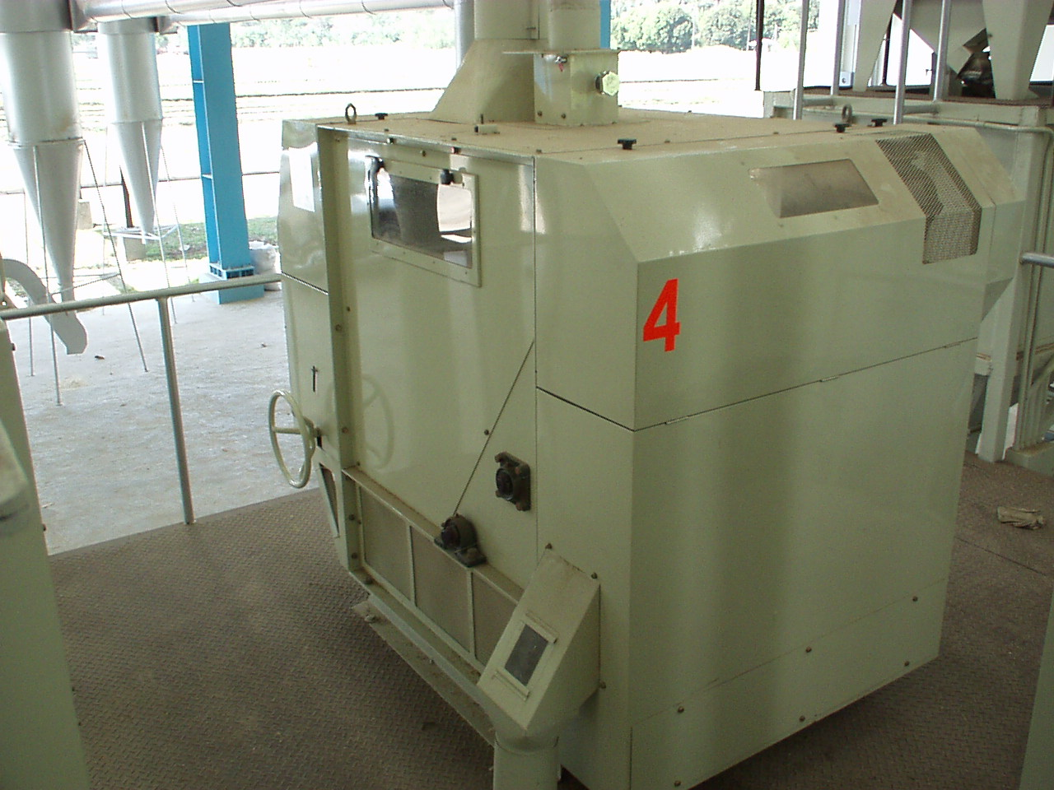
This machine is the same as a single drum with aspiration and oscillating sieves but has an additional special arrangement for separating stones that have the same physical dimensions as paddy. Of particular importance is the direction of flow of the paddy compared to the direction of movement of the stones.

Removing the husk
The husk layer is removed from the paddy by friction and the process is called either de-husking or de-hulling. De-husking was traditionally done using mortar and pestles but, in modern rice mills, it is done by passing the paddy grains between two abrasive surfaces that are moving at different speeds. After separating the husk and paddy, the husk is removed by suction (aspirated) and then transported to a storage dump outside the milling plant. The percentage of paddy that is de-hulled to produce brown rice during this process is called the hulling efficiency An efficient husker will remove 90% of the husk in a single pass. After the husk has been removed the brown rice goes to a paddy separator. The kernels that were not de-husked in the first pass will be separated and then returned to the de-husker..
Types of Husking machines
1. Steel Huller
The steel huller removes the husks and whitens the rice in one pass. Paddy rice is fed into the machine and passes between a revolving steel shaft and a cylindrical shaped mesh screen. These machines are normally powered by a 15 to 20 hp engine and are very simple to operate. They are relatively cheap.
Advantage  - Very compact  - Easy to operate.  - Low cost and easy to maintain.  - Can mill small amount of paddy for individual farmers.  - Low cost of milling (handling and conveying equipment is minimal). | Disadvantage  - Low milling efficiency.  - Produces high amount of cracked and broken rice.  - By-products - husk, bran and very small broken are often mixed
2. Under runner disc sheller
The under-runner husker is very common in Asia. This machine has two steel discs, which have an emery coating. The upper disc is stationary and fixed to the cast iron housing. Paddy flows from a centrally located hopper between the abrasive surfaces of the revolving lower disc and the stationary upper disc. Resistance between the emery surface on the discs and the paddy grains removes the husk leaving the brown rice kernel. Brown rice and husks are then discharged circumferentially over the revolving disc and exit through an outlet. This machine is very economical to run, produces a moderate amount of cracked or broken grain, and has a hulling efficiency of about 85-90%.
Advantage  - Capacity is higher than steel huller type.  - Cracked and broken grain is less than steel huller type.  - More power efficient than steel huller type.  - Easy to operate.  - Low operation cost.  - Machine is very durable.  - It is nearly comparable to rubber rolls huller | Disadvantage  - Machine is very heavy and requires a moderate size operating space.  - This process scratches the rice kernel.  - As the abrasive stone wears, sand and silicon dislodges and mixes with rice and bran.  - Rice recovery less than the rubber rolls huller.  - Huller efficiency in this machine is 85-90%
3. Rubber roller huller
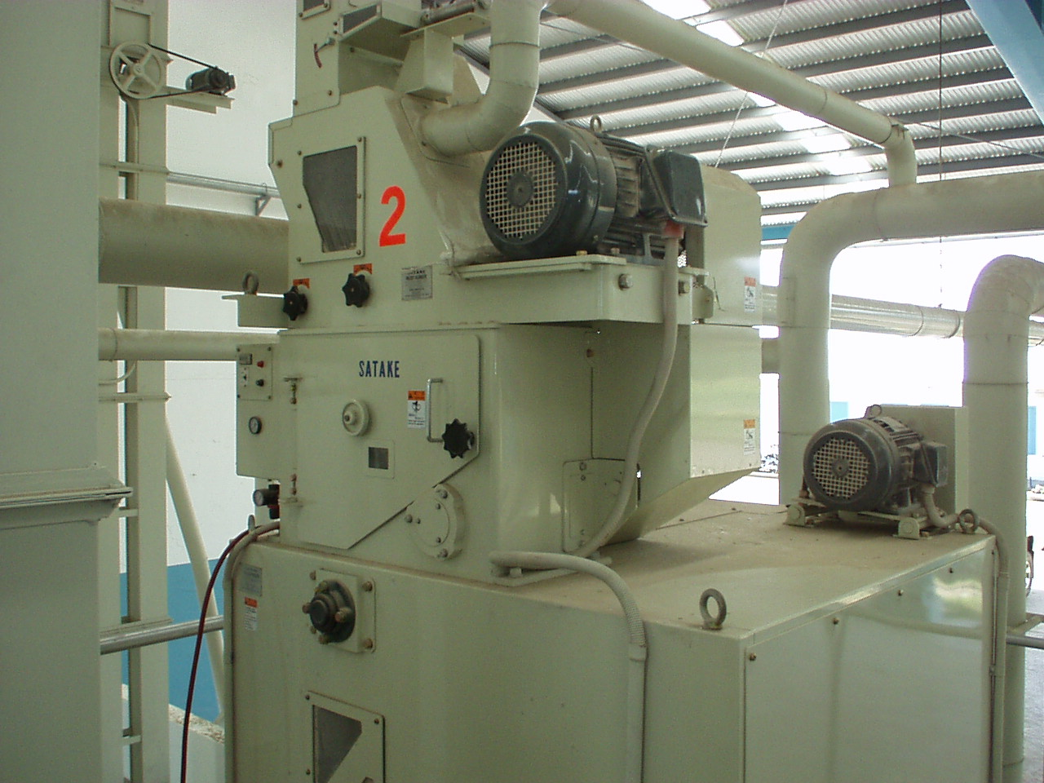
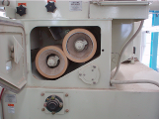
The rubber-roller huller is the most efficient hulling machine. As the name suggests two rubber rollers of the same diameter are operated at different speeds to remove the husk from the paddy. One roller has a fixed position and the other is adjustable to meet the desired clearance. The adjustable roller rotates slightly slower than the fixed roller. Rubber-roll hullers have an aspirator in the base of the machine to separate the hulls from the brown rice. The roll diameter varies from 150 to 250 mm and the roller width from 60 to 250 mm. The correct clearance is dependent on the varietal characteristics and the width and length of paddy. This method of hulling can achieve hulling efficiencies of 85% to 90% with minimum broken or cracked grain. This type of machine is now widely used in developed countries.

Advantage  - Reduce breakage of milled kernels.  - High hulling efficiency.  - By-products are free from sand and silicon.  - Bran also in higher quantities compared to disc huller  - Very compact in comparison to disc huller.  - Less vibration | Disadvantage  - Cost to purchase  - Cost of rubber rollers
.

Paddy separation
The output from the huller is a mixture of paddy rice, brown rice, husk, broken paddy, and sometimes bran. The huller aspirator removes the lighter material such as husk, bran and very small brokens. The remainder passes onto the paddy separator where the unhulled paddy rice is separated from the brown rice. The amount of paddy present depends on the efficiency of the husker, and should not be more 10%. Paddy separators work by making use of the differences in specific gravity, buoyancy and size between paddy and brown rice. Paddy rice has a lower specific gravity, higher buoyancy, and is physically bigger, longer and wider than brown rice
There are two types of paddy separator -
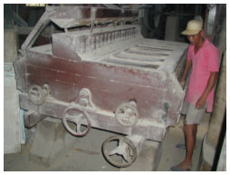
1. Compartment Separator
The compartment type of paddy separator uses the difference in specific gravity and the buoyancy to separate paddy and brown rice. When paddy and brown rice move over an inclined plane, they move at different speeds depending on their specific gravity, their shape and contact area, smoothness of inclined surface and the co-efficient of sliding friction. Brown grains are smaller, heavier, rounder and smoother and will slide faster than paddy grains. The processing capacity of the compartment separator is dependent on the compartment area. For a 2-ton/hr capacity rice mill, a 45-compartment separator made up of 15 compartments on each of three decks is used.
2. Tray Separator
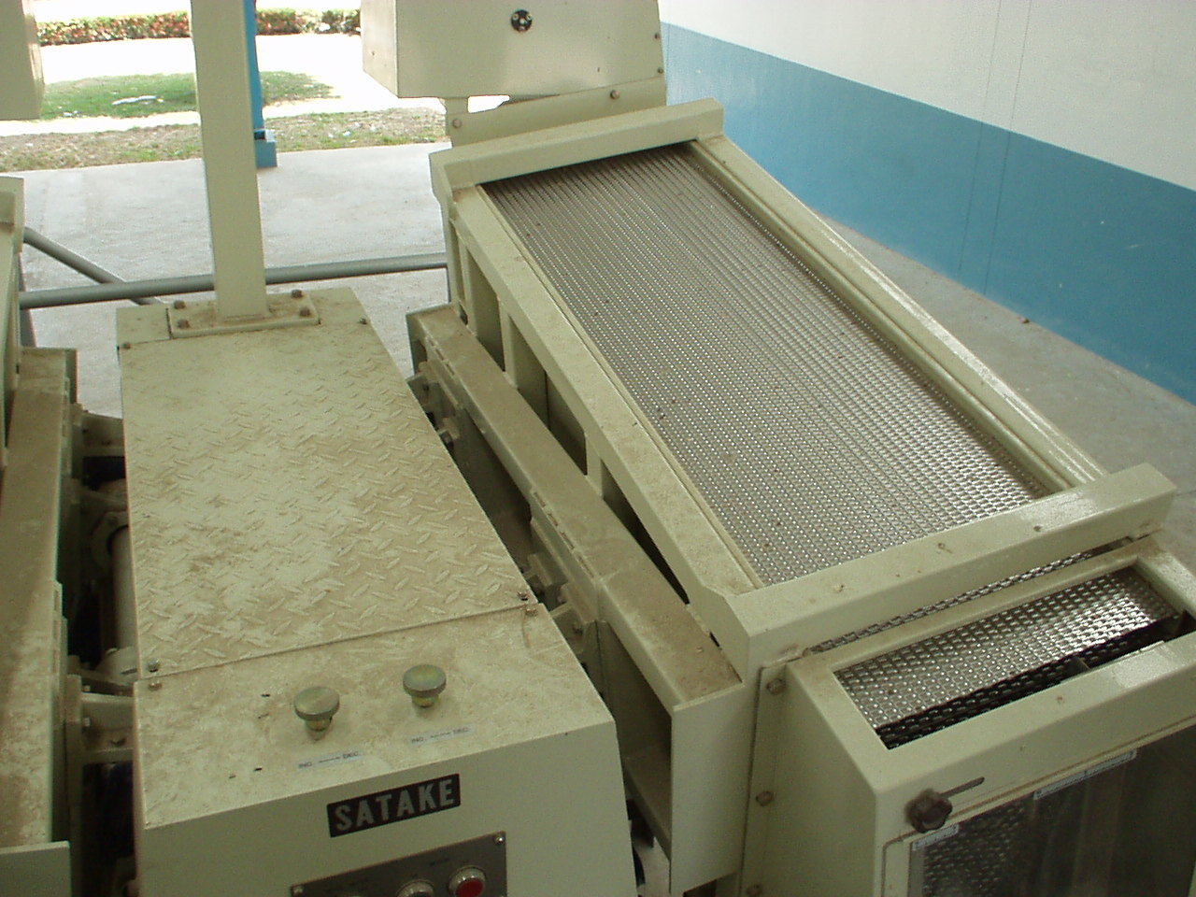
The tray separator uses the differences in specific gravity, grain length and the co-efficient of friction to separate paddy and brown rice. The oscillation and slope of the tray forces the brown rice to move up the slope and the paddy to slide down. The separation performance of this type of paddy separator is very good. This machine is very compact, easy to adjust, and consumes less power than the compartment type separator.
Separation Principle
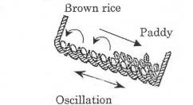
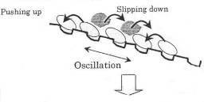
Hulling Efficiency
In principle, the huller can efficiently remove between 80 and 95% of the husk from the paddy in one pass. When setting up a rubber huller it is normal to have 10% of the paddy returned for a second hulling. If efficiencies higher than this are attempted the level of grain breakages will increase.

Whitening or Polishing Process
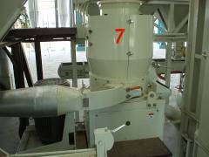
White rice is produced from brown rice by removing the bran layer and the germ. The bran layer is removed from the kernel by applying friction to the grain surface either by rubbing the grains against an abrasive surface or against each other. The amount of bran removed is normally between 8-10% of the total paddy weight but this will vary according to the variety and degree of whiteness required.
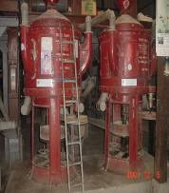
The process used to whiten brown rice can be classified as either abrasive or friction.

Abrasive: In this process the grain is whitened by the abrasive action of the rice kernel passing between a moving abrasive surface and stationary screen. The hard rough surface is usually stone or a carborundum type material. The abrasive process applies less pressure on the grain and is better suited for long grain varieties. Abrasive polishers can be either vertical or horizontal in design. The vertical cone whitener is very common in many Asian countries.
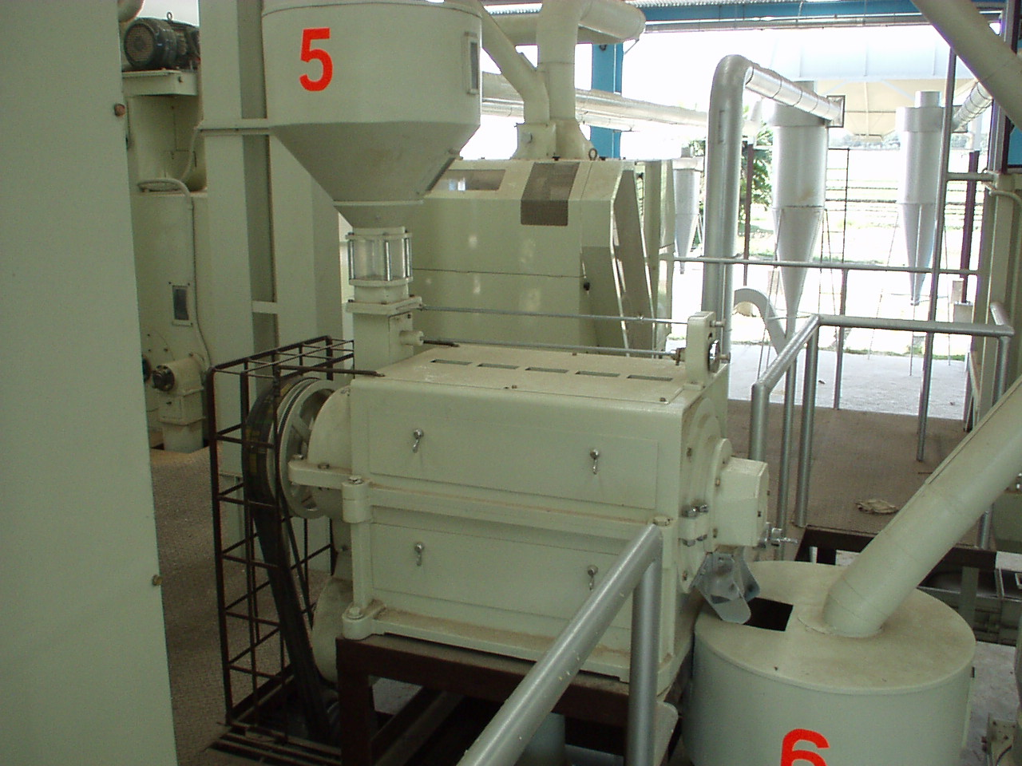
Friction. In the friction whitener the grain kernels are forced against each other and a metal screen by a steel-ribbed cylinder rotating inside a metal-plated cylinder. The frictional forces created between individual rice grains and between the grains and the metal screen surface remove the bran layer from the grain. Friction polishers are always horizontal in design and apply more pressure on the grain than an abrasive whitener.
The whitening process applies pressure to the grain, which generates heat and causes cracking and breakage of some kernels. To reduce the number of broken grains and the grain temperature during the whitening process, rice is normally passed through two to four whitening and polishing machines connected in series. Rice temperatures should not exceed 43-44⁰C during any process. The arrangement of machines to process the rice during rice whitening is dependent on the physical characteristics rice grains. Proper sequencing of the machines will help reduce the amount of broken kernels during whitening and polishing. The normal arrangement of whitening and polishing long and short grain rice is as follows.
Short grain:

Abrasive
Friction
Friction
Polishing

Long grain
Abrasive
Abrasive
Polishing

Separation of white rice
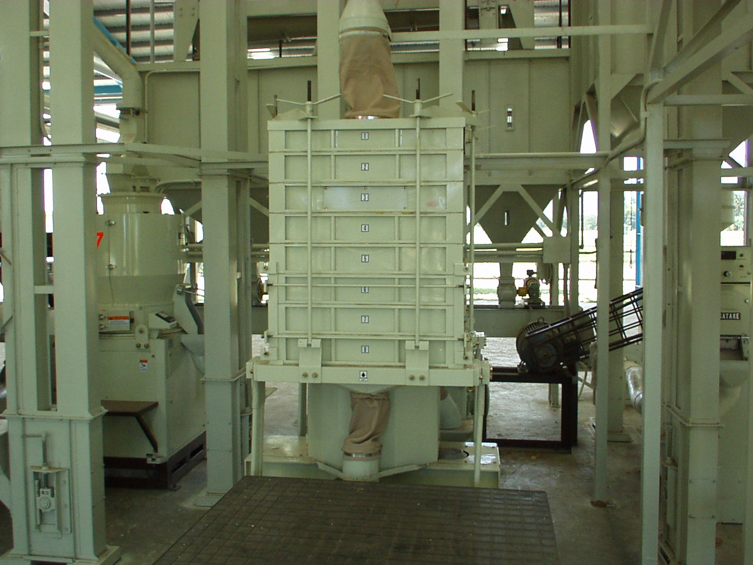
After polishing, the white rice is separated into head rice and, large and small broken rice by a sifter. Head rice is normally classified as kernels, which are 75-80% or more of a whole kernel. The sifter is made up of a series of oscillating screens through which the rice passes. The output from the bottom screen is the very fine broken tips and is called the “brewers”.

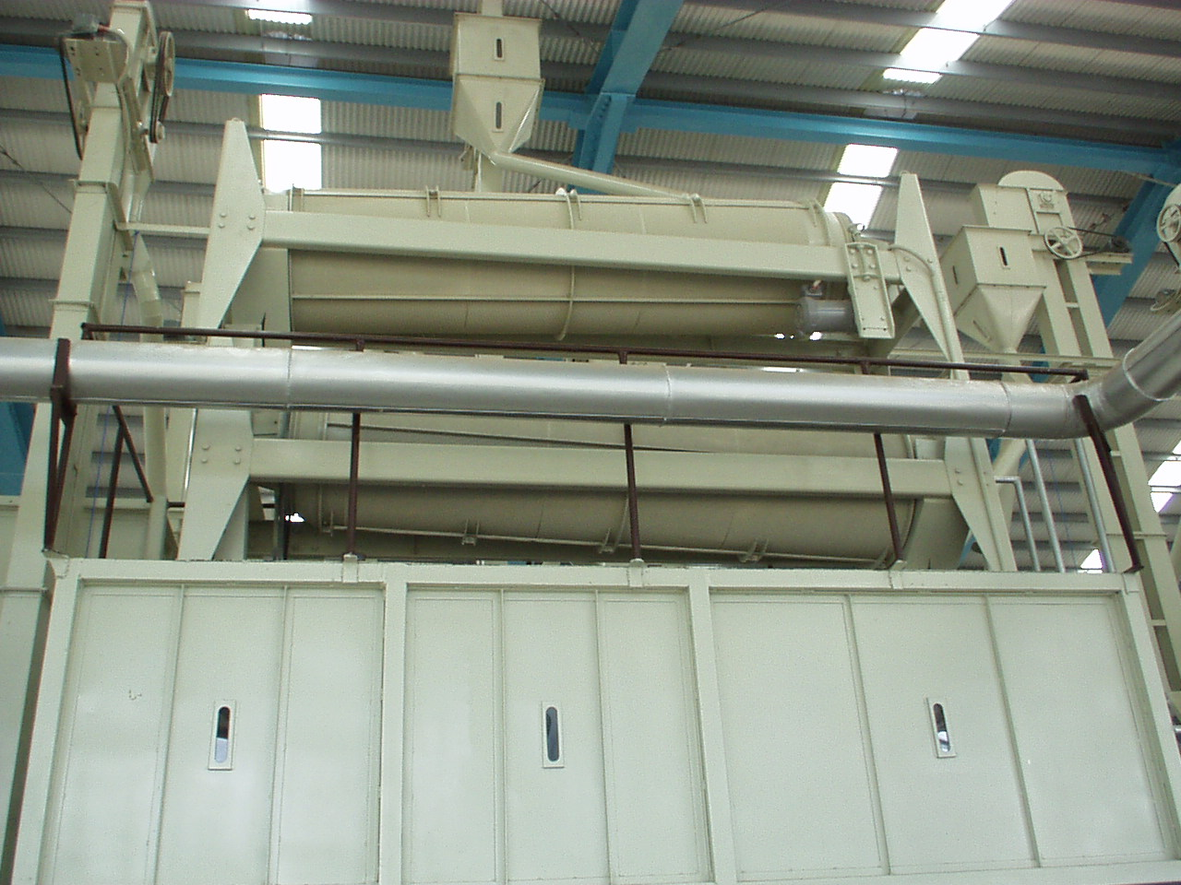
To attain a higher degree of precision for grading and separation, a length or indent grader is also used. This machine is made up of 1-3 rotating indented cylinders. The broken and smaller rice pieces fall into the indents on the rotating roller surface and are removed leaving the whole rice kernels or head rice.
Different indent sizes are used according to the size of the grain

Rice Mixing
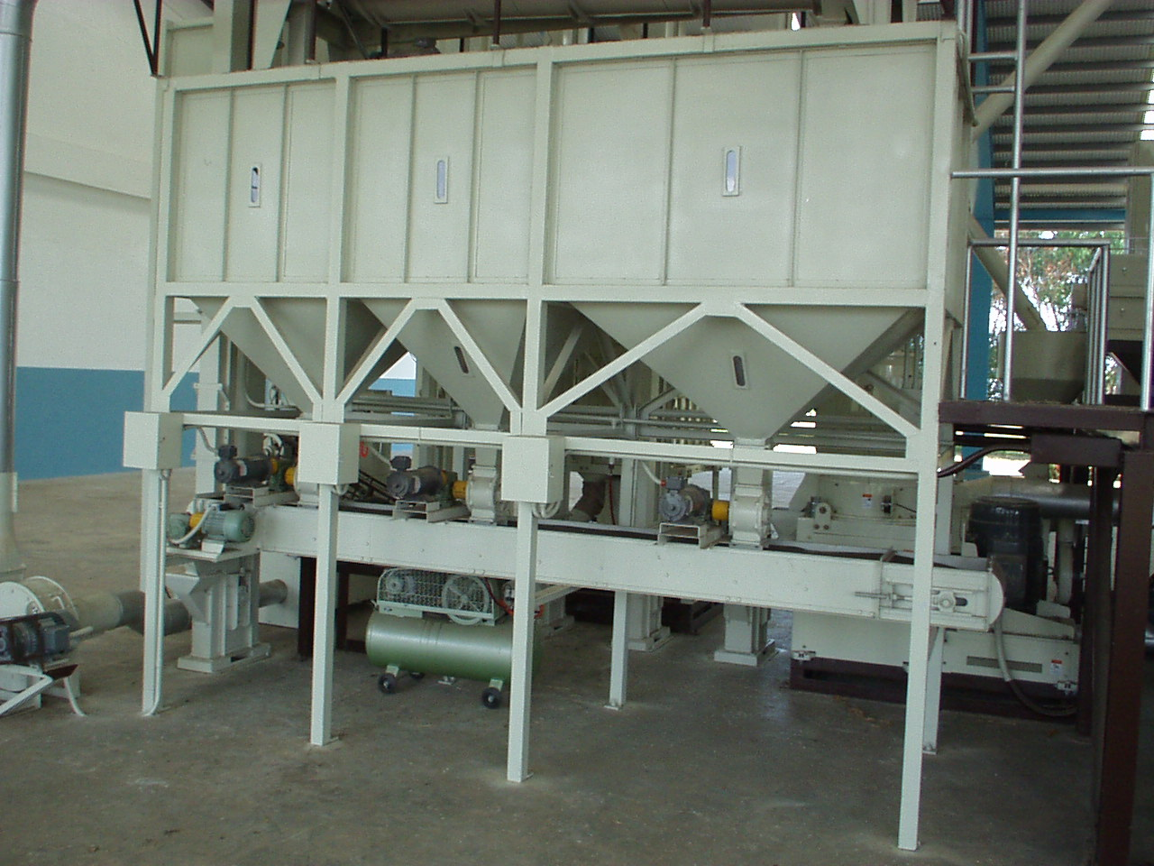
A good rice mill will produce 50-60% head rice (whole kernels) 5-10% large broken and 10-15% small broken kernels. Depending on the country’s standards, rice grades in the market will contain from 5-25% broken kernels. If rice mixing is to be done properly a volumetric mixer is necessary.

Mist Polishing
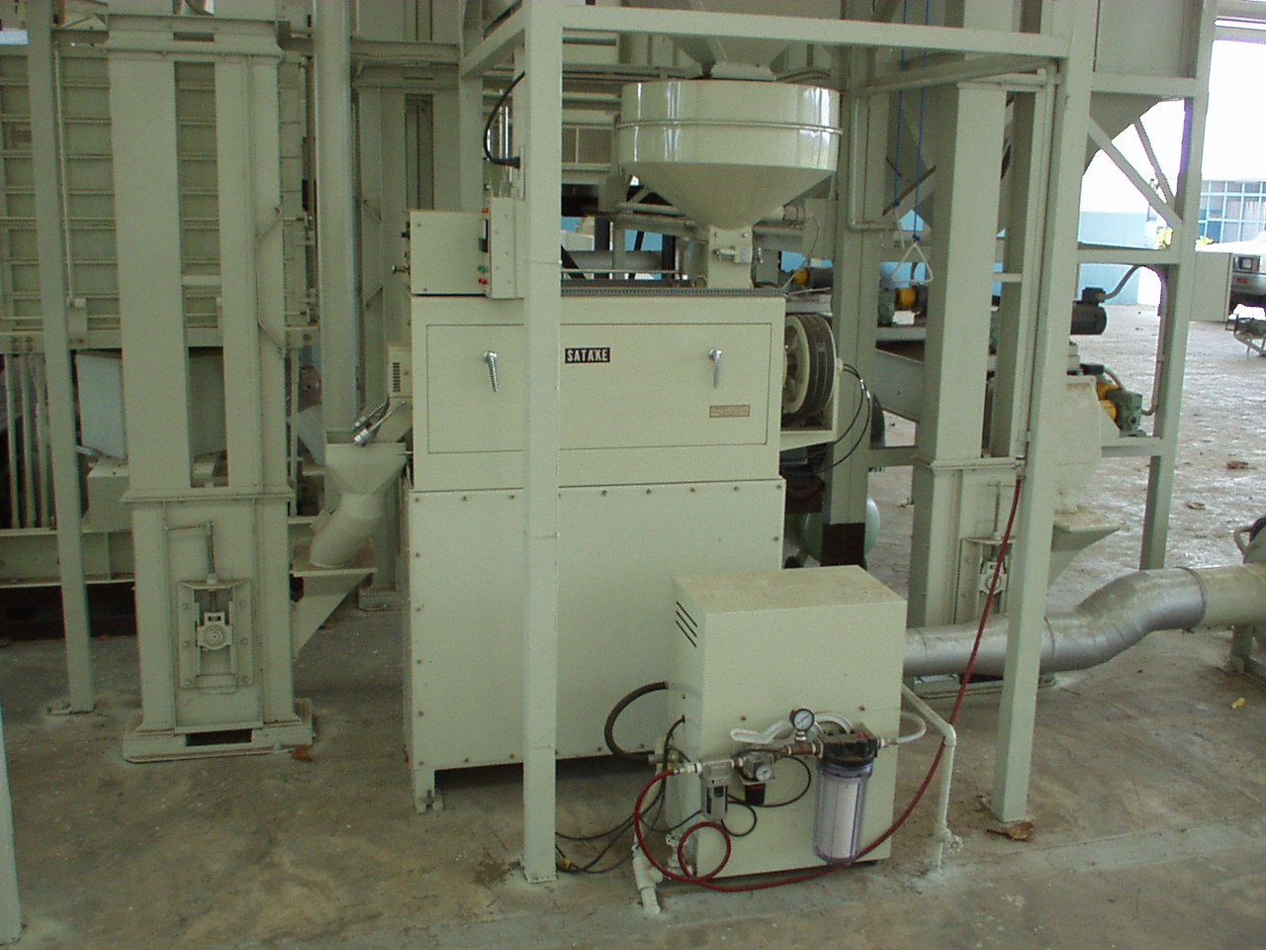
Mixing a fine mist of water with the dust retained on the whitened rice improves the luster of the rice (polishes) without significantly reducing the milling yield. A friction type-whitening machine, which delivers a fine mist of water during the final whitening process, is used for “final” polishing before sale.

Rice Weighing
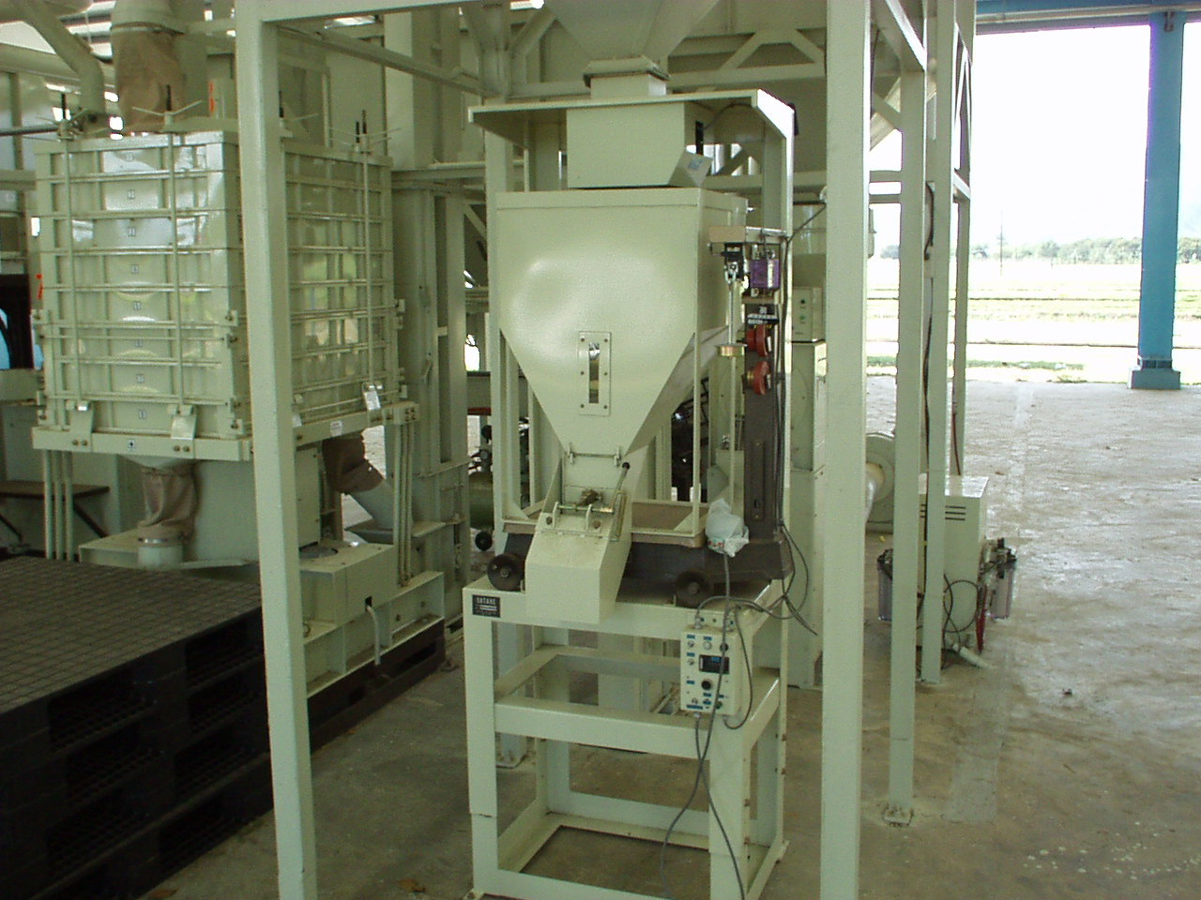
Rice is normally sold as 50kg sacks which must be accurately weighed and labeled. While most rice mills use a manual, mechanical weighing system, very accurate and fast electronic systems are also available.

